Values-centered Leadership®
  - A Model for Work and Life

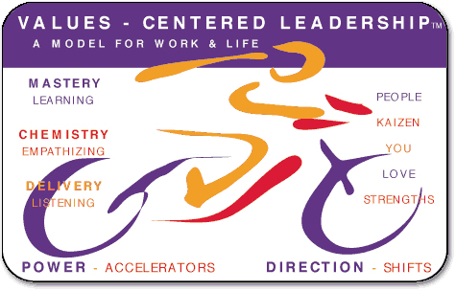

The Vector

Current Position

(A) (B) Difference
The Primary Values Score The Accelerators Score (B)-(A)
0-10 0-10
MASTERY  Undertaking whatever you do to the highest standards of which you are capable. |  | LEARNING  Seeking and practicing knowledge and wisdom.
CHEMISTRY  Relating so well with others that they actively seek to associate themselves with you. |  | EMPATHIZING  Considering the thoughts, feelings and perspectives of others.
DELIVERY  Identifying the needs of others and meeting them  . |  | LISTENING  Hearing and understanding the communications of others.

Coaching Goals and Aspirations
What Do You Want to Achieve? What are You Prepared to do to Get There?

MASTERY |  | LEARNING
CHEMISTRY |  | EMPATHIZING
DELIVERY |  | LISTENING

