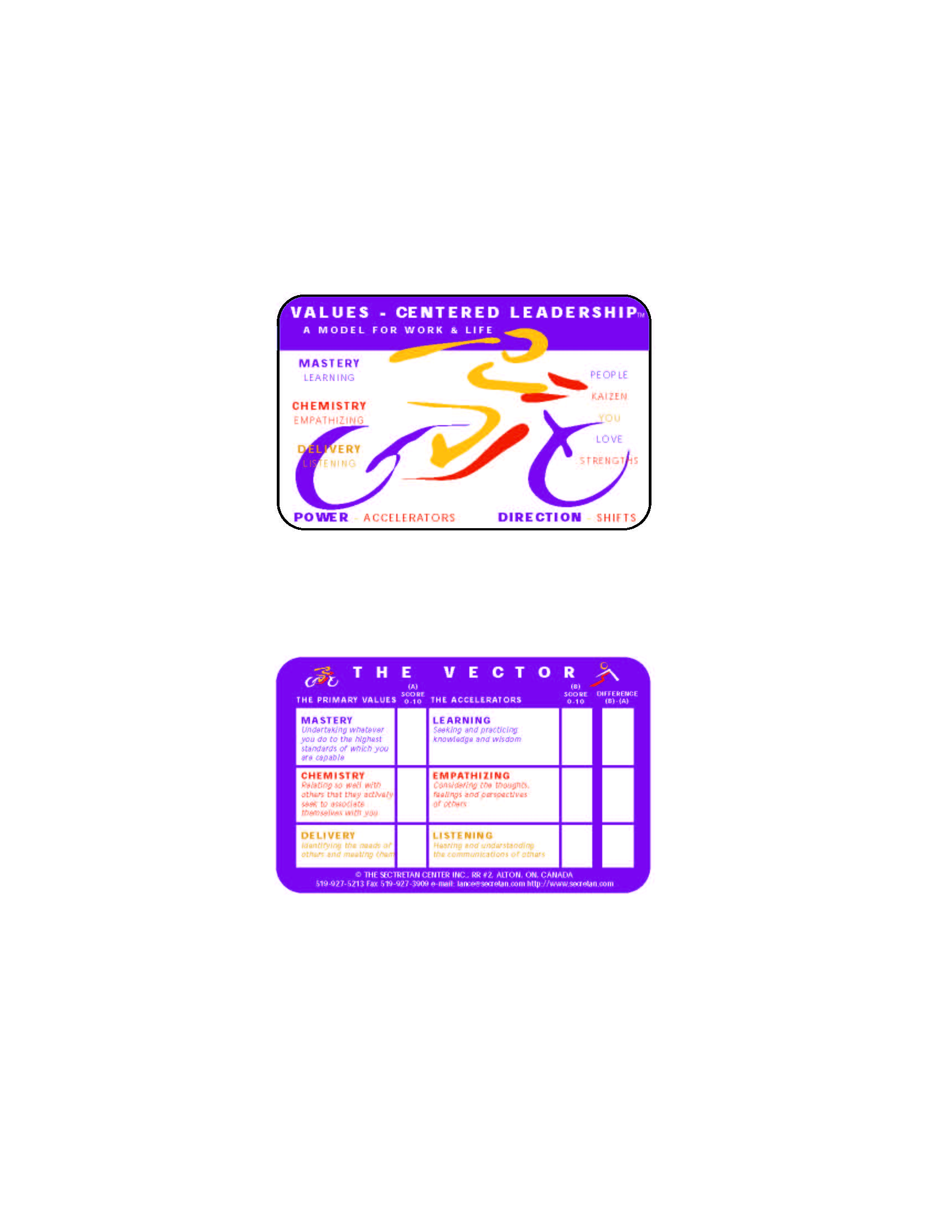

Personal Development Discussion for
_______________________________________

Personal Development Discussion:

What is most energizing about your work?
What are you passionate about?

What gives you meaning and fulfillment?
What achievement are you most proud of?
What matters to you?

What do you like least about your work?
What is inhibiting your success?

What would you change if you could?
What can I/we do differently to best assist you?

Are we fully utilizing your talents?
What would cause you to leave?

What will it take to keep you?

What do you want to learn next and more of?
How to you plan to excel?

How can I/we support you?

NB. Please refer to your Vector Card as you complete your Personal Development Program
The Primary Value of Mastery | Definition | What are the standards you plan to set?
What are the critical tasks, skills & competencies required for your responsibilities? What does it take to reach the very highest standards—to be among the best in your field? What is the core knowledge, professional development, learning, teaching & expertise, information systems, technology & science, technique, efficiency, sophistication, artistry, & accomplishment required for your work? What overall standards are expected? What constitutes excellence? What expert knowledge is required? What skills, competencies & practices are required? What are the opportunities for continuous improvement? | Undertaking whatever you do to the highest standards of which you are capable.  Describe how that looks when you are at your best:

and Learning (the Accelerator for Mastery) | Definition | What are the standards you plan to set?
How “does the bar get raised”? What will it take to reach and exceed new and higher standards? What continuous learning is required in order to achieve the desired levels of Mastery? Where? When? Why? | Seeking and practicing knowledge and wisdom.  Describe how that looks when you are at your best:

The Primary Value of Chemistry | Definition | What are the standards you plan to set?
With whom must strong relationships be built and maintained—inside and outside the organization? How & with whom are harmonious relationships to be established? What current relationships require repairing, maintaining & building? What are the characteristics & attitudes which lead to building strong relationships? How should relationships be developed beyond the superficial? What opportunities exist for establishing friendships & bonds built on trust, mutual respect, openness, vulnerability, intimacy, integrity, improved communication & truthfulness? How can more win/win partnerships be built? What are the situations where being a team player is critical? When is a gregarious style an asset? Are there situations where it is essential to be easy to get along with? Are the conditions appropriate for developing deep relationships that could result in long-lasting & profoundly rewarding business relationships—with employees (& their partners), suppliers, industry colleagues & strategic alliance partners? | Relating so well with others that they actively seek to associate themselves with you.  Describe how that looks when you are at your best:

and Empathizing (the Accelerator for Chemistry) | Definition | What are the standards you plan to set?
What are the opportunities for enhancing communication through Empathy (truthfulness, promise-keeping, trust, good communication, accountability, energy, honesty, integrity, intimacy, respect, compassion & love)? | Considering the thoughts, feelings and perspectives of others.  Describe how that looks when you are at your best:

The Primary Value of Delivery | Definition | What are the standards you plan to set?
Who are the internal & external Customers for your work? What are their needs? How is respect for the needs of others developed together with a matching passion for meeting them? How is focus brought to bear on the needs of others, inspired by enlightened self-interest & altruism? What is the balance between respecting and meeting the needs of others with making a profit & knowing that profit is the result of a successful Employee and Customer-focused philosophy? How critical is the development & implementation of “win/win” deals & relationships? To what extent are others treated as partners rather than as a means to an end? Is there a clear mechanism to distinguish between doing the right thing & doing things right? What mechanisms exist to define clear standards of performance & results for both internal & external Customers? | Identifying the needs of others and meeting them.  Describe how that looks when you are at your best:  _

and Listening (the Accelerator for Delivery) | Definition | What are the standards you plan to set?
What is the means by which listening is achieved in order to meet the needs of internal & external Customers? How is attentiveness being developed to a high level in order to maximize an understanding of the communications of others? What are the means by which “mental chatter” is shut down & undivided attention given to others when communicating with them? What skills & practices are required to look for other signals when listening besides words, such as body language, intonation & expression? How well developed is the skill of “hearing the words as well as the music”? Is there a propensity to listen openly, and in the most effective way possible, in order to understand, without being defensive or manipulative? | Hearing and understanding the communications of others.  Describe how that looks when you are at your best:

