What Kind of Company do You Want XXXXXX Inc. to Be? 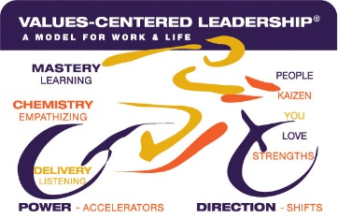

Comparable  (7-8) | Distinctive  (8-9) | Breakthrough  (9-10)

MASTERY
(Product or Service)
CHEMISTRY
(Relationships)
DELIVERY
(Service and Quality)

