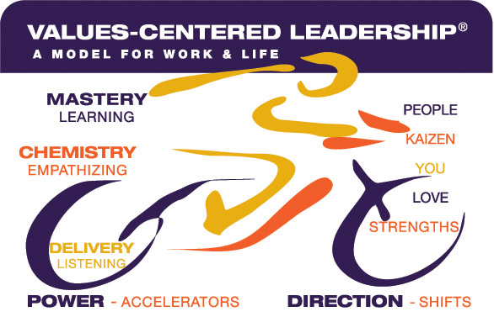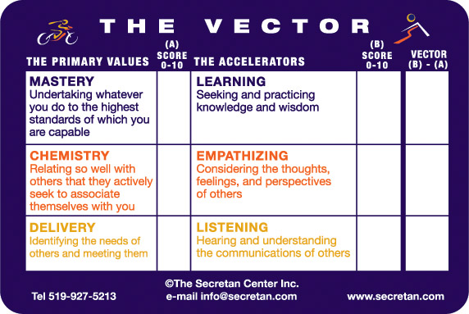

PRIMARY VALUES | ASPIRATION  “A” | VALUE  TODAY  0-10 | ACCELERATOR | ASPIRATION  “B” | VALUE  TODAY  1-10 | VECTOR  (B-A)
MASTERY  What skill do you wish to grow? |  |  | LEARNING  What will you need to learn?
CHEMISTRY  With whom do you wish to build a stronger relationship? |  |  | EMPATHY  How will you Empathize more with them?
DELIVERY  How can you be of greater service, and to whom? |  |  | LISTENING  How, and to whom, will you Listen?

