Workshop: The Spark, the Flame and the Torch
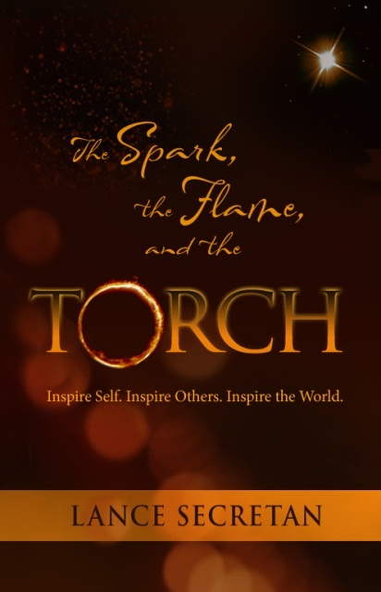
In this workshop based on Dr. Lance Secretan’s groundbreaking book, The Spark, the Flame and the Torch: Inspire Self. Inspire Others. Inspire the World, he will guide you in practical ideas, exercises and processes and engage in invigorating conversations with participants.

This will be a challenging, dynamic and very practical workshop in which new ideas will be explained and demonstrated, leading to a greater awareness of self, others and the role of leadership in changing self, others and the world.

You will learn:
- The Spark: How to Regenerate Your Personal Level of Inspiration.
  - Define your North Star—The Why-Be-Do
  - Raise Performance by Building Powerful Relationships
  - Create a Corporate Dream
- The Flame: How to be a More Inspiring Persona and Leader with Others.
  - The CASTLE® Principles
- The Torch: New Approaches to Coaching, Mentoring and Developing Leaders.
  - Values-centered Leadership®

Says Marc Benioff, Chairman and CEO, salesforce.com:
"Lance Secretan—through the use of his inspiring CASTLE® Principles—shows us how to transform, stretch, and excite an organization to a new level of performance and excellence."

